Talking about your week-end….

**+++** = great/ excellent/ cool/ super/ terrific

**+**= nice/ fine/ interesting

**++-** = all right/ok/ not so bad/ rather nice

**+-- =** soso/not so fine/rather bad

**-** = bad/ not fine/ boring/

**- -** = very bad/ horrible/ terrible

* =

How was your week-end ?

Did you enjoy it?

What did you do ? What happened ?

I had a ….week-end ! My week-end was…

E:\TEXT\ClipArt3\j0238461.wmf

OUTDOOR ACTIVITIES E:\TEXT\ClipArt4\j0240107.wmf E:\TEXT\ClipArt4\j0240061.wmf E:\TEXT\ClipArt4\j0240055.wmf 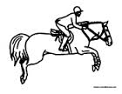 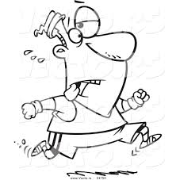

**I went** SWIMMING CYCLING FOR A WALK HORSE-RIDING JOGGING

FUNNY ACTIVITIES E:\TEXT\ClipArt1\j0078756.wmf E:\TEXT\ClipArt3\j0233051.wmf E:\TEXT\ClipArt3\j0238229.wmf 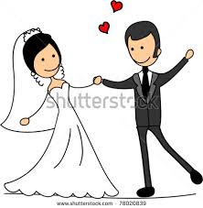 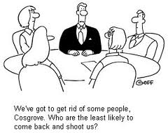

**I had/ was invited to** a BARBECUE PICNIC PARTY WEDDING MEETING

DAILY CHORES E:\TEXT\ClipArt2\j0229913.wmf E:\TEXT\ClipArt2\j0229897.wmf E:\TEXT\ClipArt3\j0237647.wmf E:\TEXT\ClipArt1\j0198772.wmf E:\TEXT\ClipArt1\j0078774.wmf 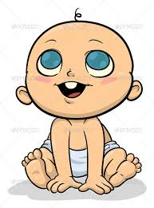

**I did the** HOME-WORK SHOPPING CLEANING COOKING ODD JOBS BABYSITTING

RELAXING ACTIVITIES E:\TEXT\ClipArt3\j0232905.wmf E:\TEXT\ClipArt3\j0232988.wmf E:\TEXT\ClipArt3\j0232976.wmf E:\TEXT\ClipArt6\j0294178.wmf EN00202_ 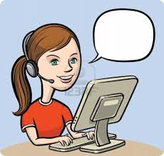

**I** RELAX**ED** READ WATCH**ED** PLAY**ED** LISTEN**ED** SURF**ED**

PLACES IN TOWN **E:\TEXT\ClipArt1\j0196186.wmf E:\TEXT\ClipArt8\j0344055.wmf E:\TEXT\ClipArt2\j0215022.wmf** 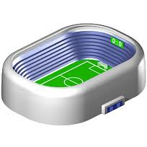 **E:\TEXT\ClipArt3\j0237595.wmf**

**I went to the CHURCH RESTAURANT SUPERMARKET STADIUM DOCTOR’S**

EXPLORING NATUREE:\TEXT\ClipArt1\j0157725.wmf E:\TEXT\ClipArt1\j0174823.wmf 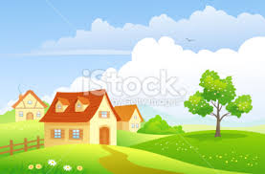 E:\TEXT\ClipArt1\j0174827.wmf

**I went to the** forest beach countryside waterfalls